**Project Objective: Design & populate an** [**IMDb**](http://www.imdb.com/) **database**

Database Design Requirements:

* Use IMDb web pages or mobile interface to identify entities and relationships (list below)
* Identify IMDb “page”
  + list entities and relationships on that page
  + list entities related on pages linked to that page

Data Source:

* Use [IMDb Alternative Interfaces](http://www.imdb.com/interfaces) and/or input sample data for each entity

List of IMDb application “pages” to use for requirements:

* 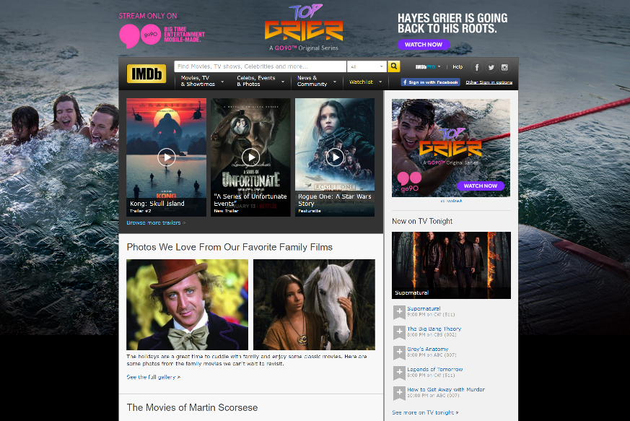[Home](http://www.imdb.com/?ref_=nv_home)
* Movies
  + [In Theaters](http://www.imdb.com/movies-in-theaters/?ref_=nv_mv_inth_1)
  + [Showtime & Tickets](http://www.imdb.com/showtimes/?ref_=nv_mv_sh_2)
  + [Latest Trailers](http://www.imdb.com/trailers/?ref_=nv_mv_tr_3)
  + [Coming Soon](http://www.imdb.com/movies-coming-soon/?ref_=nv_mv_cs_4)
  + [Release Calendar](http://www.imdb.com/calendar/?ref_=nv_mv_cal_5)
  + [Top Rated Movies](http://www.imdb.com/chart/top?ref_=nv_mv_250_6)
  + [Most Popular Movies](http://www.imdb.com/chart/moviemeter?ref_=nv_mv_mpm_8)
* Charts & Trends
  + [Box Office](http://www.imdb.com/chart/?ref_=nv_ch_cht_1)
  + [Oscar Winners](http://www.imdb.com/search/title?count=100&groups=oscar_best_picture_winners&sort=year,desc&ref_=nv_ch_osc_2)
  + [Most Popular by Genre](http://www.imdb.com/genre/?ref_=nv_ch_gr_3)
* TV & Video
  + [On Tonight](http://www.imdb.com/tvgrid/?ref_=nv_tvv_ls_2)
  + [Top Rated TV Shows](http://www.imdb.com/chart/toptv/?ref_=nv_tvv_250_3)
  + [Most Popular TV Shows](http://www.imdb.com/chart/tvmeter?ref_=nv_tvv_mptv_4)
  + 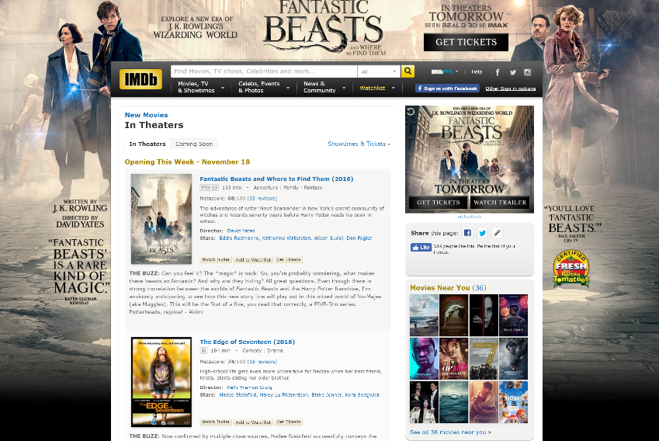[Watch Now on Amazon](http://www.imdb.com/feature/watch-now-on-amazon/?ref_=nv_tvv_wn_5)
  + [DVD & Blu-Ray](http://www.imdb.com/sections/dvd/?ref_=nv_tvv_dvd_6)
* Celebs
  + [Celebrity News](http://www.imdb.com/news/celebrity?ref_=nv_cel_nw_2)
* Events
  + [Awards Central](http://www.imdb.com/awards-central/?ref_=nv_ev_awrd_1)
* News
  + [Top News](http://www.imdb.com/news/top?ref_=nv_nw_tp_1)
  + [Movie News](http://www.imdb.com/news/movie?ref_=nv_nw_mv_2)
  + [TV News](http://www.imdb.com/news/tv?ref_=nv_nw_tv_3)
  + [Celebrity News](http://www.imdb.com/news/celebrity?ref_=nv_nw_cel_4)
  + [Indie News](http://www.imdb.com/news/indie?ref_=nv_nw_ind_5)
* Community
  + [Polls](http://www.imdb.com/poll/?ref_=nv_cm_pl_3)

Deliverables:

* Create ER model for entities and relationships identified in your design requirements
* Use TOAD Data Modeler to document
  + Submit TOAD data model file
  + Submit images of ER model (or sub-models)
* Create databases to implement your ER model
  + Microsoft SQL Server
  + Oracle
  + Hive
* Database Design
  + Submit list of tables & columns
  + Submit list of indexes, triggers, constraints or other dataset objects
* Load sample data into each of your databases
* Create a list of questions a IMDB user might be searching for when using IMDb application
* Create SQL queries to answer the above questions for both SQL Server & Oracle
  + Submit questions to be answered, SQL queries and query result set

**Deliverables:**

1. **ER Model Design - Toad File:**



1. **ER Model Design - Image File:**



1. **Data Sheet: (Data Inserted)**



1. **MS SQL - DDL - Scripts**



1. **SQL – Queries and PL/SQL Queries Consolidated**



1. **Entities and Attributes List**



1. **Queries based on the designed IMDB database and its Entity:**
2. Get the list of Movies screened in Theaters of Screen type IMax and price is less than $40 for an Adult category

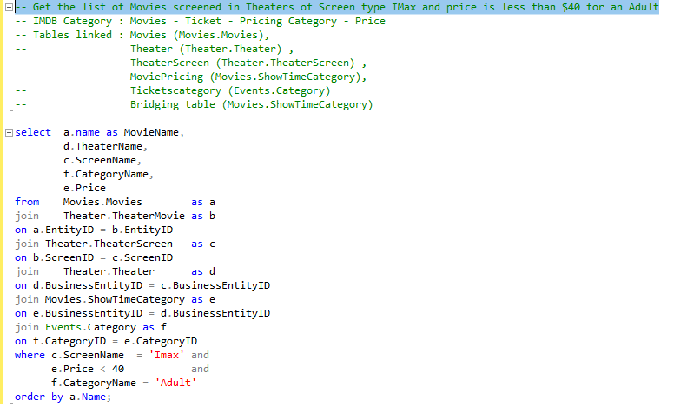

Output:

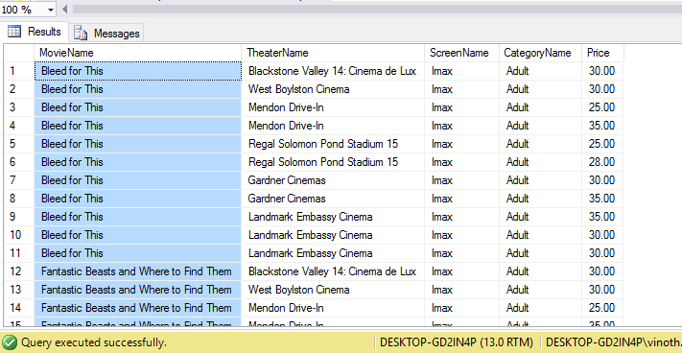

1. Rank movies with PG13-certificate whose Total Weekend Turnover is more than its budget

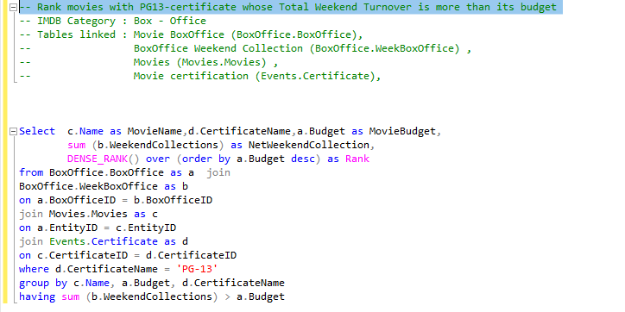

Output:

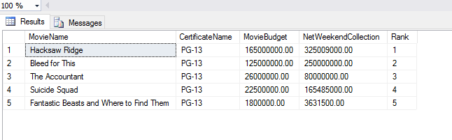

1. Get all details of the Cast and Crew - Personal details and Images (search Cast and Crew – Biographies)

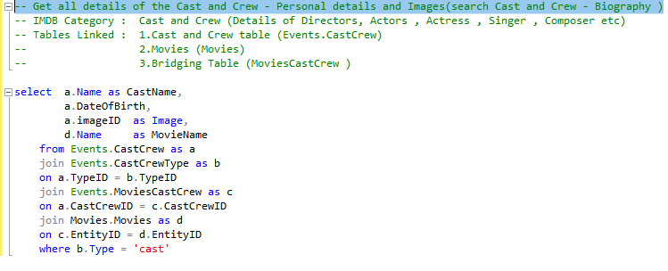

Output:

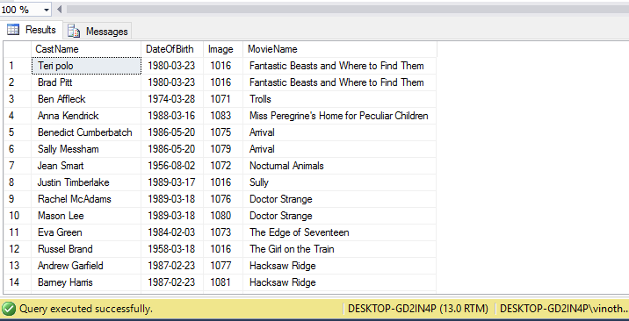

1. Get the Report of the Movies screened in theaters by geo-Hierarchy

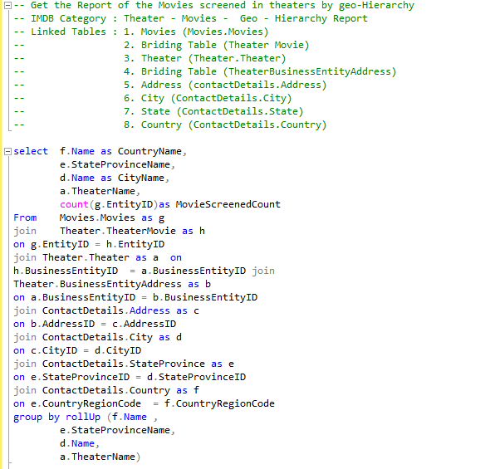

Output

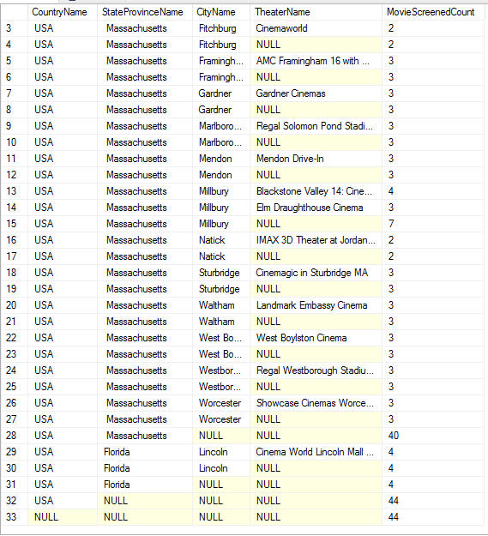

1. Get all the Choice Count and for each Poll choices of the polls created since the last five days

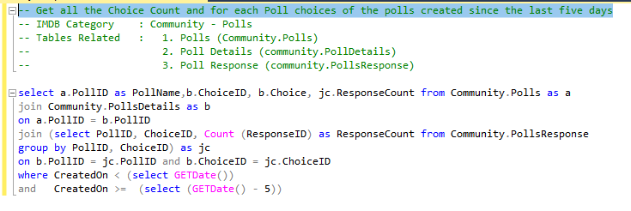

Output

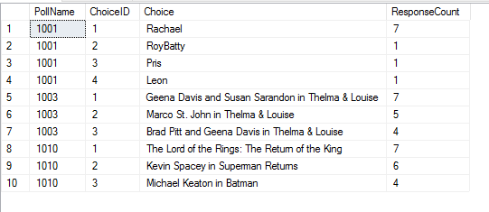

1. Get the list of Reporters and the Link to the information Source of Top News for each category

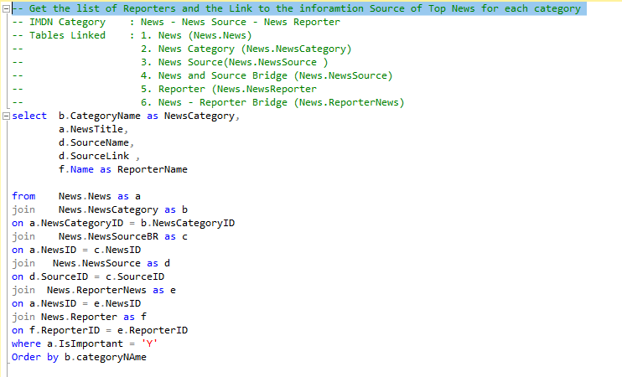

Output

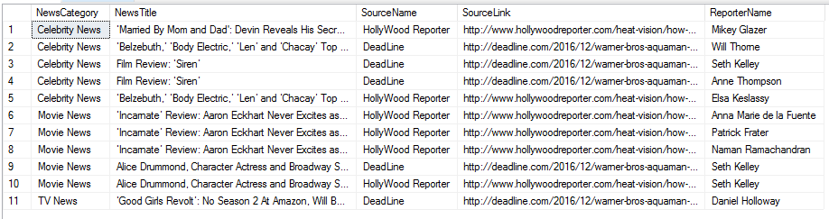

1. Get list of cast and crew for a given Movie using table Valued Function 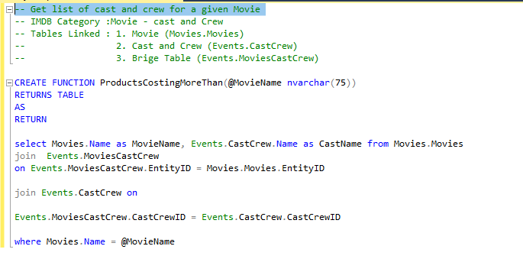

Output

select * from ProductsCostingMoreThan ('Arrival')

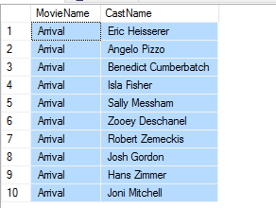

1. **PL/SQL – Procedures, Triggers and Functions**
2. Procedure 1 - Procedure to do search on Movie - to display the list of theaters in which the movie is screened

also with the list of Screenname and Price for each category with the ShowTime



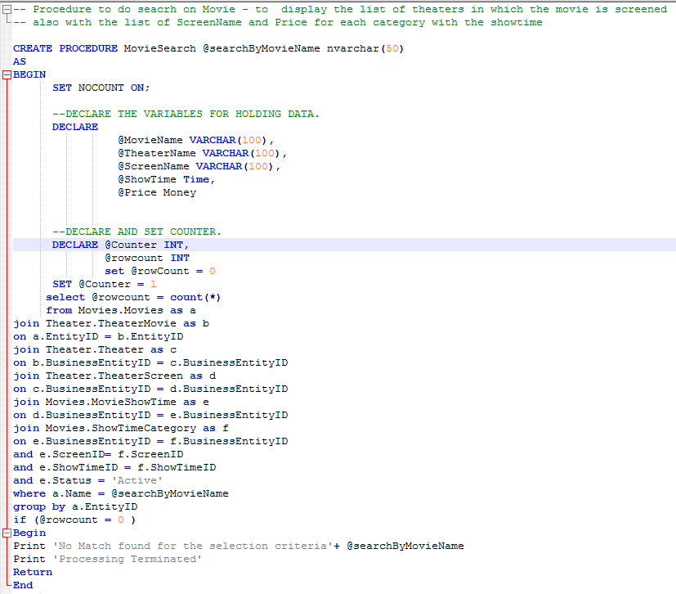

Output:

Execute MovieSearch 'Doctor Strange'

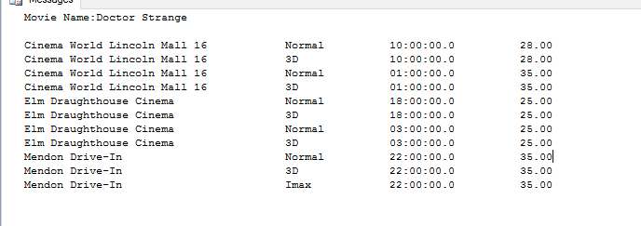

1. Procedure 2 - Creating a Backup File for the Database (IMDB- Database) with Timestamp

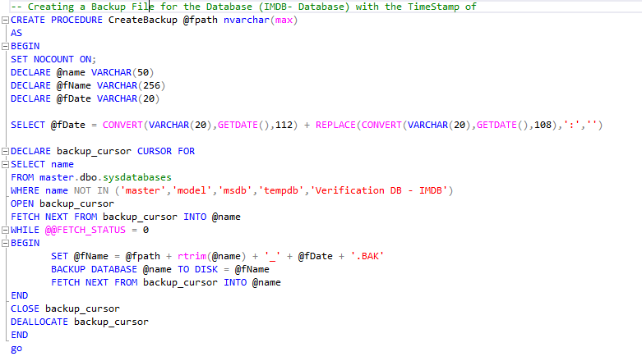

Output

execute CreateBackup 'C:\Program Files\Microsoft SQL Server\MSSQL13.MSSQLSERVER\MSSQL\Backup\'

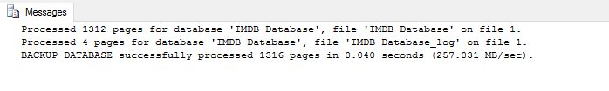

1. Function to calculate the Maximum Weekend Turn Over for a given Movie

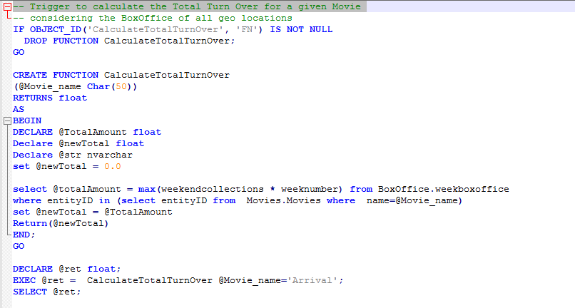

Output

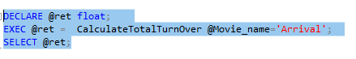

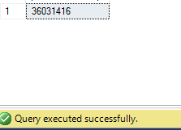

1. Trigger 1 - Trigger to update the Votes and rating based on the user reviews from the review table

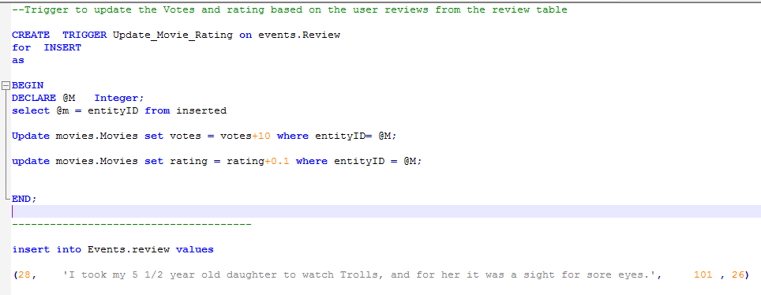

Output



1. Trigger to update the Age and Registration of any IMDB user on First Login

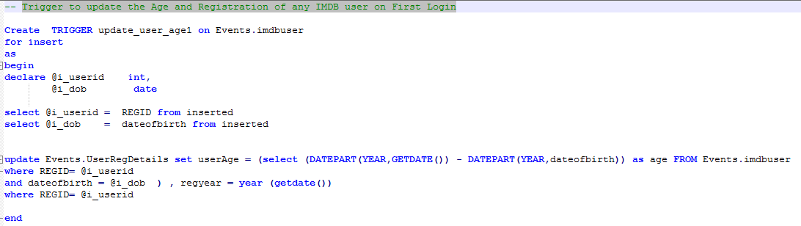

Output

